THE INTERNATIONAL SCIENTIFIC CONFERENCE:

DISCOURSES OF CHILDHOOD AND SOCIAL EDUCATION

2nd – 3rd June 2022, The Maria Grzegorzewska University, Warsaw, Poland

SCIENTIFIC COMMITTEE

Africa:
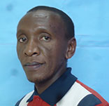 Gatitu Kiguru, PhD, Kenyatta University, Kenya
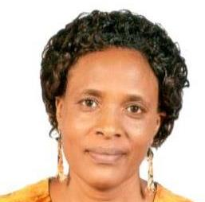 Phyllis W. Mwangi, PhD, Kenyatta University, Kenya

Americas:
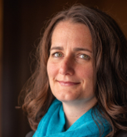 Prof. Kathleen Manion, Royal Roads University, Canada
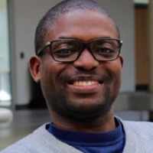 Taiwo Afolabi, PhD, University of Regina, Canada
Prof. Darrick Smith, University of San Francisco, USA
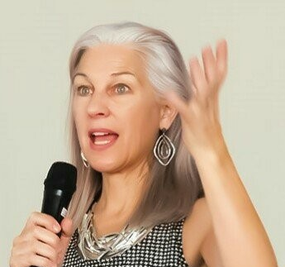 Prof. Kathleen Tacelovsky, Lebanon Valley College, USA
Cecilia Zsogon, PhD, University of Buenos Aires, Argentina

Europe:
Prof. Rudi Roose, Agent, Belgium
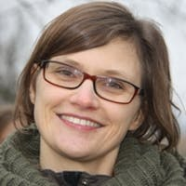 Prof. Lieve Bradt, UGent, Belgium
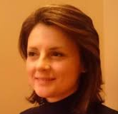 Assc. prof. Višnja Rajić, PhD, University of Zagreb, Faculty of Teacher Education
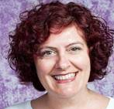 Asst. prof. Adrijana Višnjić-Jevtić, PhD, University of Zagreb, Faculty of Teacher Education
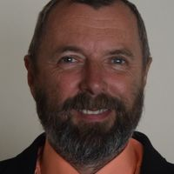 Prof. Ivo Jirásek, Tomas Bata University in Zlín, Czech Republic
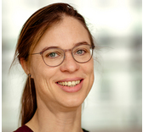 Rebecca Budde, PhD, Potsdam University of Applied Sciences, Germany

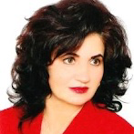 Prof. Florica Ortan, University of Oradea, Romania
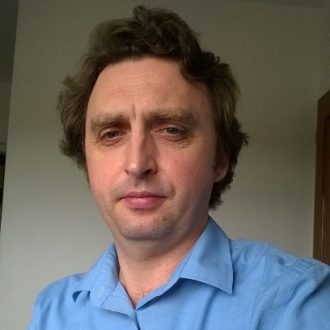 Julien Kiss, PhD, University of Oradea, Romania
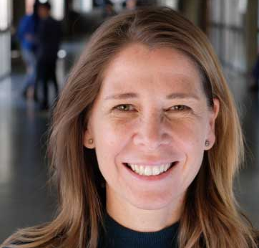 Adriana Aubert Simon, PhD, Universitat de Barcelona, Spain (RN10 coordinator)
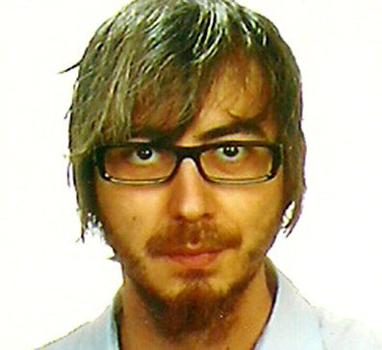 Cecilio Lapresta-Rey, PhD, University of Lleida (UDL), Spain
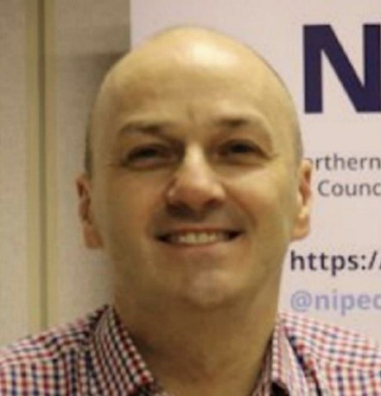 Professor Michael Brown, Director of Graduate Studies in the School of Nursing and Midwifery at Queen's University, Belfast, UK
Prof. Claire Cameroon, UCL, UK
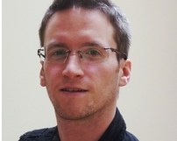 Dr Gabriel Eichsteller, ThemPra Social Pedagogy, UK

Middle East:
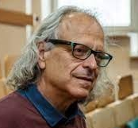 Prof. Moshe Shner, Oranim Academic College, Israel

Poland:
Prof. dr hab. Agnieszka Cybal-Michalska, UAM, KNP PAN
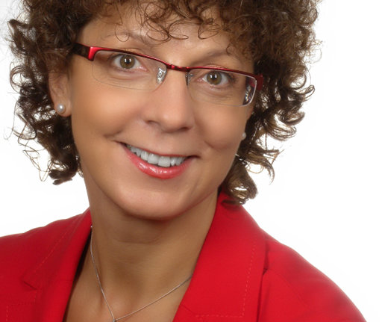 Prof. dr. hab. Joanna Madalińska-Michalak, UW, WERA
Prof. Piotr Kostyło, UKW, PTP
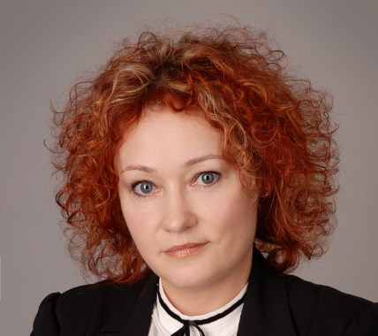 Prof. Joanna Ostrouch-Kamińska, UWM
Prof. Jerzy Nikitorowicz, UwB
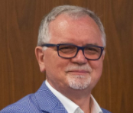 Prof. Miroslaw Sobecki UwB
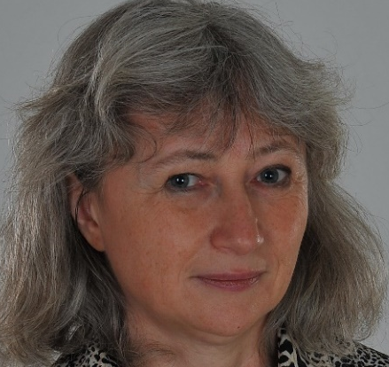 Prof. Agnieszka Naumiuk, UW
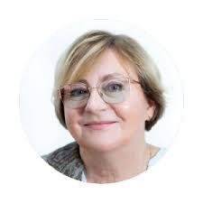 Prof. Danuta Lalak, UW
Prof. Alicja Szerląg UWr
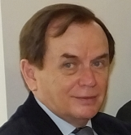 Prof. dr hab. Mirosław Szymański, APS
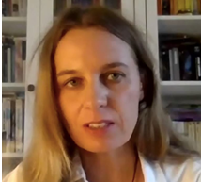 Prof. Anna Perkowska-Klejman, APS
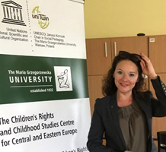 Prof. Anna Odrowąż-Coates, APS

ORGANIZING COMMITTEE
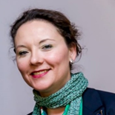 Prof. Anna Odrowąż-Coates, APS
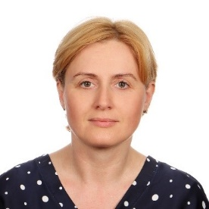 Dr Ewa Dąbrowa, APS
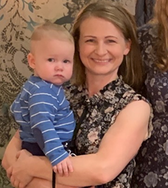 Dr Krystyna Heland-Kurzak, APS
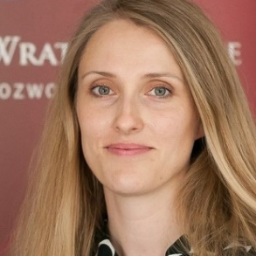 Dr Monika Czyżewska, APS
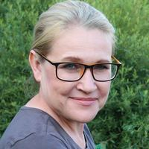 Dr Magda Lejzerowicz, APS
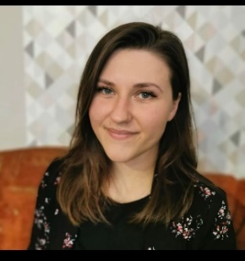 Joanna Pawłowska, PERA PTP
Claudia Chovgrani, APS

