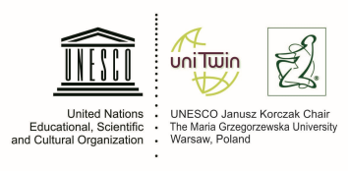

11th International Summer School

"International experiences in the area of refugee and migrant children's adaptation - theory, research, praxis"

7-16 September 2017, Warsaw, Poland

organised by
the UNESCO Janusz Korczak Chair at the Maria Grzegorzewska Academy of Special Education
in cooperation with
The Polish National Commission for UNESCO
and Bureau for Academic Recognition and International Exchange – CEEPUS Programme

Participant data

First and middle names:

Family name:

Nationality:

Date and place of birth:

Passport number:

Permanent address and zip code:

E-mail:

The name of full address of the University:

Work position:

University degree; Diplomas:
Research area:

References - List two persons /titles, e-mail/ who can provide information on qualifications of candidate

1.……………………………………………………………………………………………………………………………..

2. ……………………………………………………………………………………………………………………………..
The “Participant data” duly completed should be sent electronically,
no later than 30 January 2017 to: unescochair@aps.edu.pl

